KATHRON — DAHLESING EP – CLOCKWORK VOLTAGE

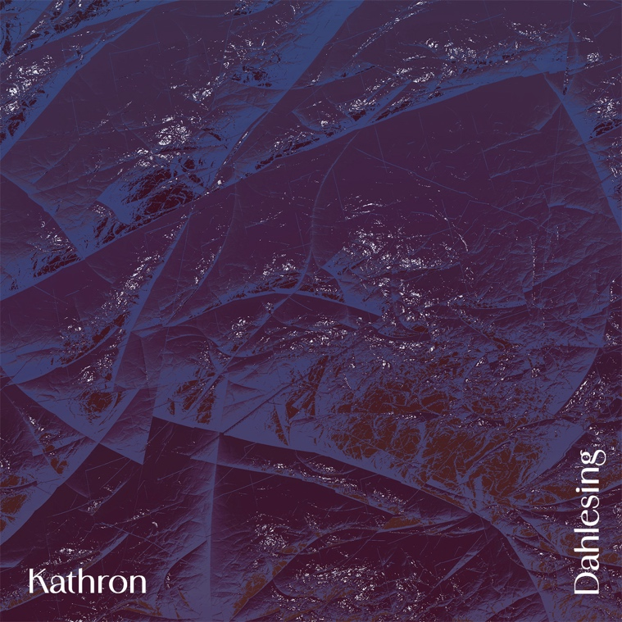

Produced by Kathron
Mixed and mastered by Aleš Hieng - Zergon
Artwork by Candela Solver

https://clockworkvoltage.bandcamp.com/album/kathron-dahlesing-ep

From the darker, hypnotic edges of techno emerges Kathron, a DJ and producer from Ljubljana, whose sonic storytelling explores the balance between raw energy and emotional depth. Active since 2018, she first developed her sound within the Cooltura Electronica collective, later refining her technical skills at Radio Študent, where she works as a sound engineer and curates the show Flash Forward.

An important step in her artistic evolution came through the Clockwork Voltage community, where she further developed her approach to live electronic performance and shaped her distinctive, hypnotic flow.

Coinciding with her performance at MENT Ljubljana, she presents her new EP Dahlesing, a release via the Clockwork Voltage community that captures her signature sound, driving rhythms, dark atmospheres, and gradual tension-building that pulls listeners deep into the night.

You can catch Kathron on Friday, 20 February, at Klub Gromka, where she’ll deliver a powerful clubbing live set — intense, atmospheric, and uncompromising.

Come early, stay late.
Dahlesing is here — and the night is only beginning.

